

JNJ rolls out patient and HCP websites to support ICOTYDE’s launch

Company: JNJ  Drug: Icotyde (icotrokinra, oral IL-23R antagonist) | Date: March 20, 2026  Source(s): Icotyde Patient Website, Icotyde HCP Website

What happened:
- Following the FDA approval of ICOTYDE for the treatment of adults and adolescents aged 12+ years with moderate-to-severe plaque psoriasis on March 18, 2026, the patient and HCP websites for ICOTYDE are now fully activated
- Both websites provide information about the MoA, efficacy and safety results from the ICONIC program, dosing, and resources; unicorn imagery used to signal novelty
- For HCPs, ICOTYDE is framed as a “First choice systemic therapy with proven safety profile in a once daily pill”
- For patients, ICOTYDE is positioned as “A new kind of treatment in a once-daily pill”

Impact (CI PoV): HIGH
- The rapid rollout of ICOTYDE patient and HCP websites underscores JNJ’s launch preparedness and strategy to engage both target patients and clinicians

Why it matters
- This early digital activation is critical, as HCP websites will help shape prescribing behavior through clinical education, efficacy/safety data, and treatment positioning
- Patient websites will drive awareness, and facilitate informed discussions with physicians, together accelerating early uptake and adoption
Tell me more:
- ICOTYDE websites have used a unicorn to symbolize the unique nature of the therapy (the first oral IL-23 inhibitor) that delivers convenience, efficacy, and safety in an oral peptide
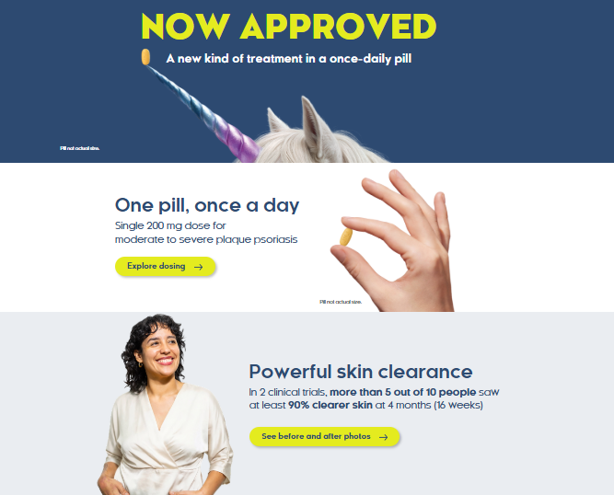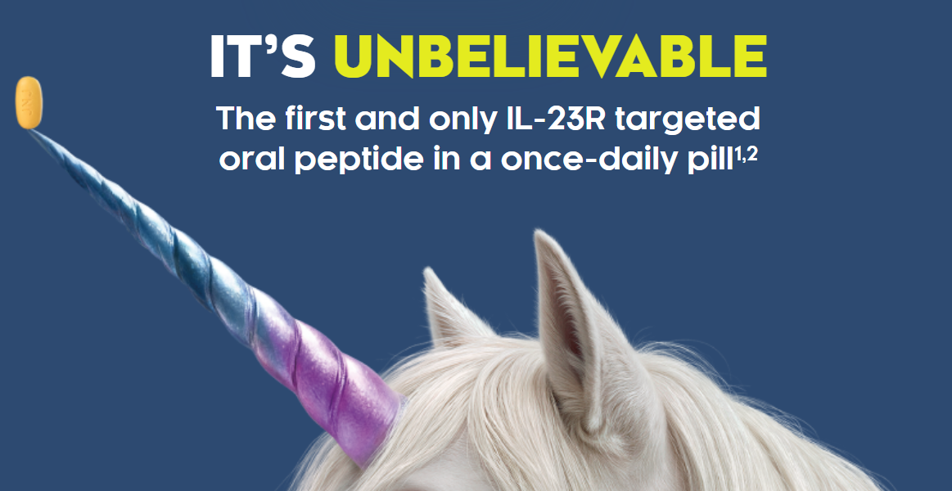

- About ICOTYDE:
  - Details how ICOTYDE targets IL-23 pathway and inhibits the IL-23/IL-23R–dependent release of proinflammatory cytokines
  - The HCP website also has a video describing the MoA
  - “The first and only IL-23R targeted oral peptide in a once daily pill”
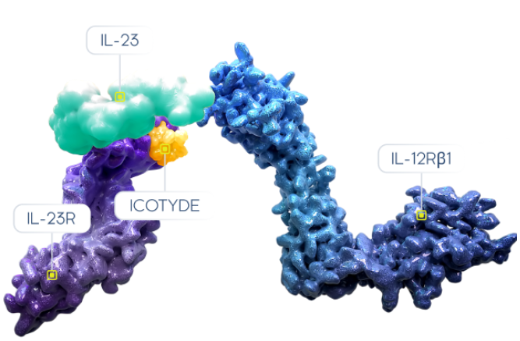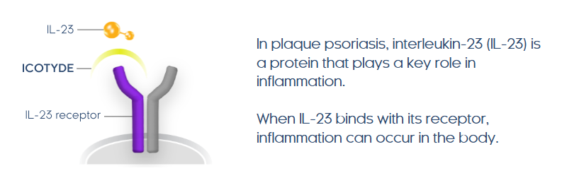
- Results:
  - While the HCP website offers details into the ICONIC program (ICONIC-LEAD, ICONIC-TOTAL and ICONIC-ADVANCE 1 & 2) covering the trial design and results, the patient website only provides an overview of efficacy and how the study was done
  - The messaging centers around “clearer skin” with ICOTYDE, with “completely clear skin in ~1 In 2 patients at week 24” in both adults and adolescents
  - Results from ICONIC-TOTAL study are reinforced with the messaging “clearer skin in hard-to-treat areas” and “significant improvement in itch symptoms”
  - Before and after photos are included in both websites

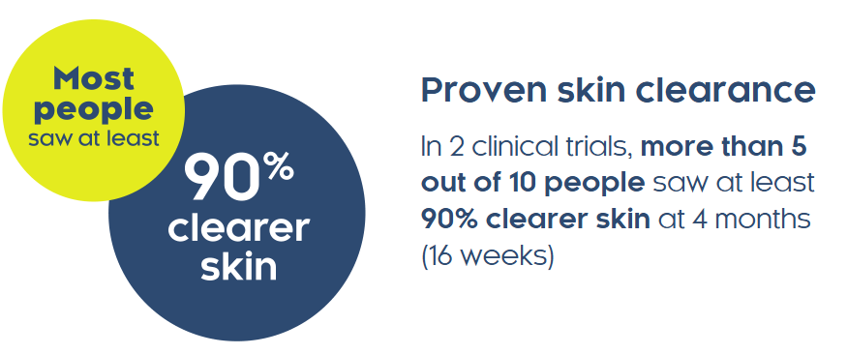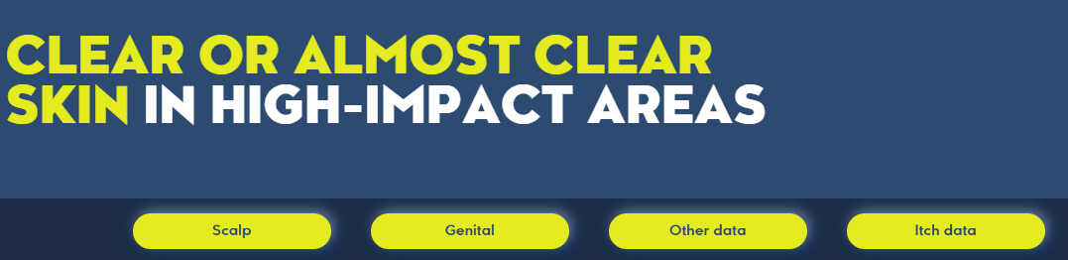

- Safety:
  - Messaged as a safe drug with data from 4 clinical trials and 2300+ patients

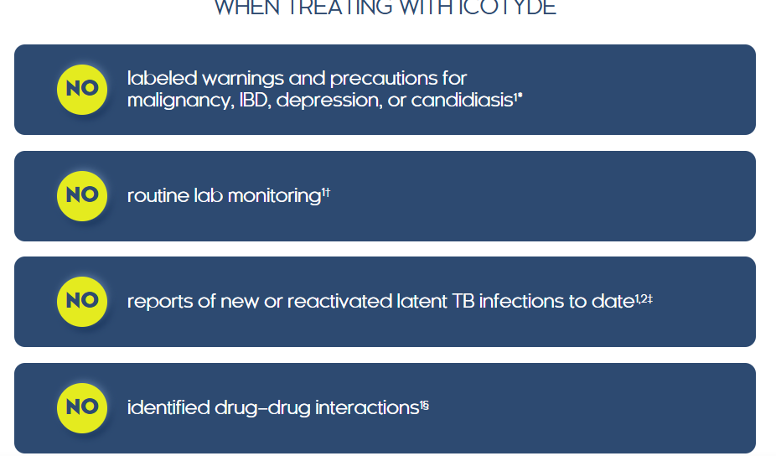
- Taking ICOTYDE:
  - The websites emphasize the convenience of a once daily pill
  - Benefits for patients and HCPs are respectively mentioned with alternative administration highlighted for patients who have trouble swallowing pills

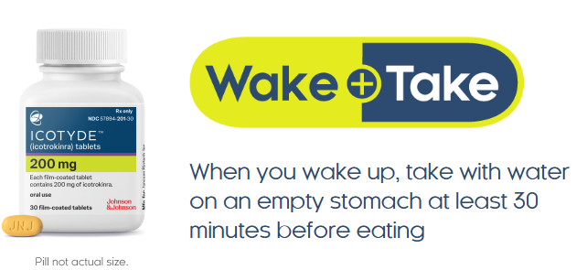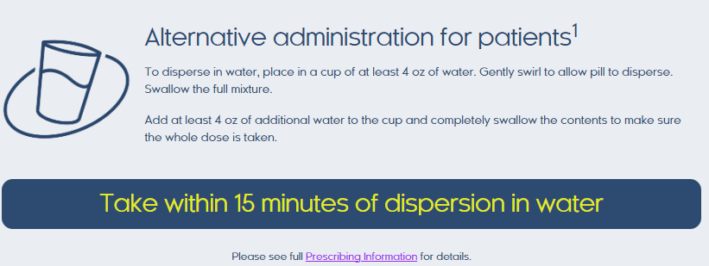
- Resources:
  - Patient website:
    - A patient brochure, Doctor Discussion Guide, and ICOTYDE withMe materials are available to support treatment education and discussion with physicians
    - ICOTYDE withMe is positioned as a free support program offering prescription and cost support, patient portal access, and a dedicated Nurse Guide
  - HCP website:
    - The website provides HCP tools including provider portal access, benefits verification, prior authorization support, and affordability programs to streamline prescribing
    - Additional tools include nurse assistance, adherence resources, and educational materials
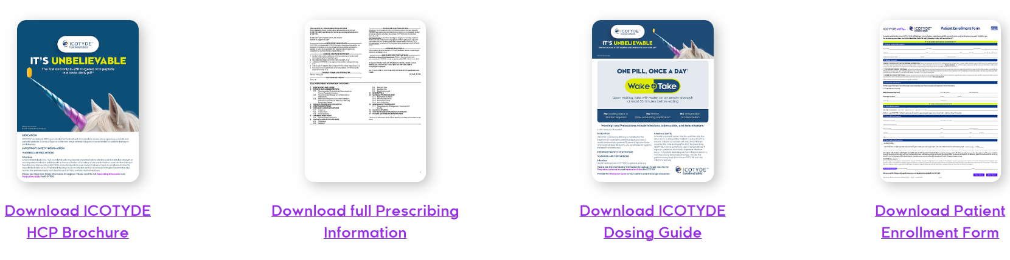

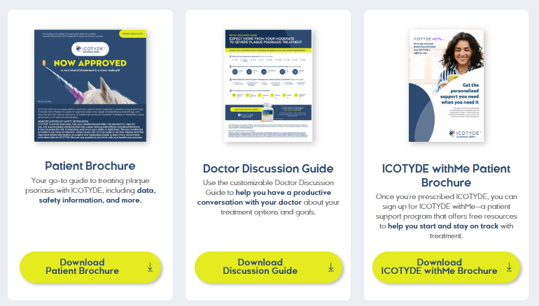

For questions, please reach out to:
 | Dermatology | Rheumatology | Gastroenterology
APEX (US/PCS) | Chanda Bhat | Bethany Christmann | Luke Versten
IMABI (International/ Affiliates) | Priti Anand | Irene Knorn | Priti Anand

Invite your colleagues to inVision | Manage Email Preferences | Unsubscribe

This document/email contains competitive intelligence collected via an approved competitive intelligence supplier working on behalf of AbbVie. We collect competitive intelligence consistent with industry standards and AbbVie policy. Not for field distribution. Please reach out to APEX/IMABI, Legal, or OEC teams with any questions.

